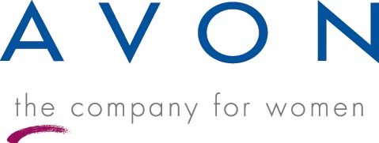
Step up to
Earning Opportunities
with
For More Information Call:

- Free Delivery to You
- Earn up to 50%
- Free Training
- Set Your Own Hours
- National Health Care Access Program
- Retirement Plans 401(a)
- Quality Daily Need Products -- Valued Priced
- On-Line Ordering
1-800-For-Avon or www.Avon.com

